Pandemic Unemployment Assistance (PUA)

Pandemic Unemployment Assistance (PUA) has been established for workers who do not qualify for regular unemployment benefits, extended benefits or PEUC and covers claims filed 1/27/2020 – 12/31/2020. Benefits are payable under PUA for 39 weeks with a minimum and maximum weekly amount. Individuals who qualify for PUA are also entitled to the additional $600 per week in PUC for benefits weeks payable 3/29/2020 – 7/31/2020.
Individuals who qualify for PUA include:
*Self-Employed Individuals *Independent Contractors-i.e.-gig workers & uber drivers
*Those who don’t qualify monetarily for a regular UC claim

PUA filing in MiWAM – the following are screens added for the PUA filing process in MiWAM.
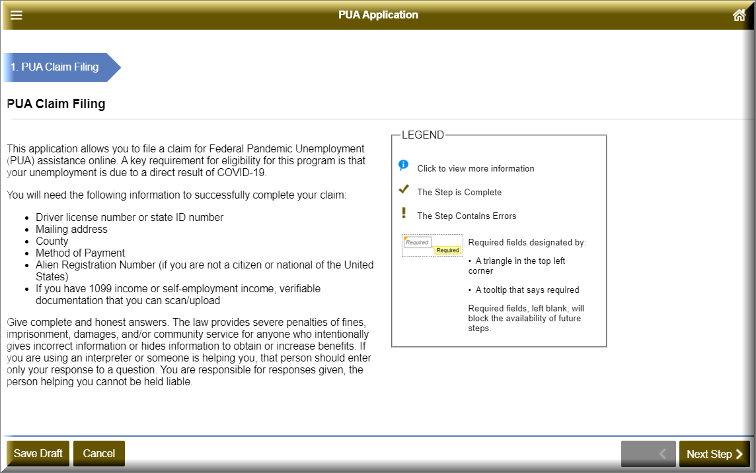
Note that this instructs claimants that they will be asked to scan/upload their 1099 income or self-employment income verifiable documentation.
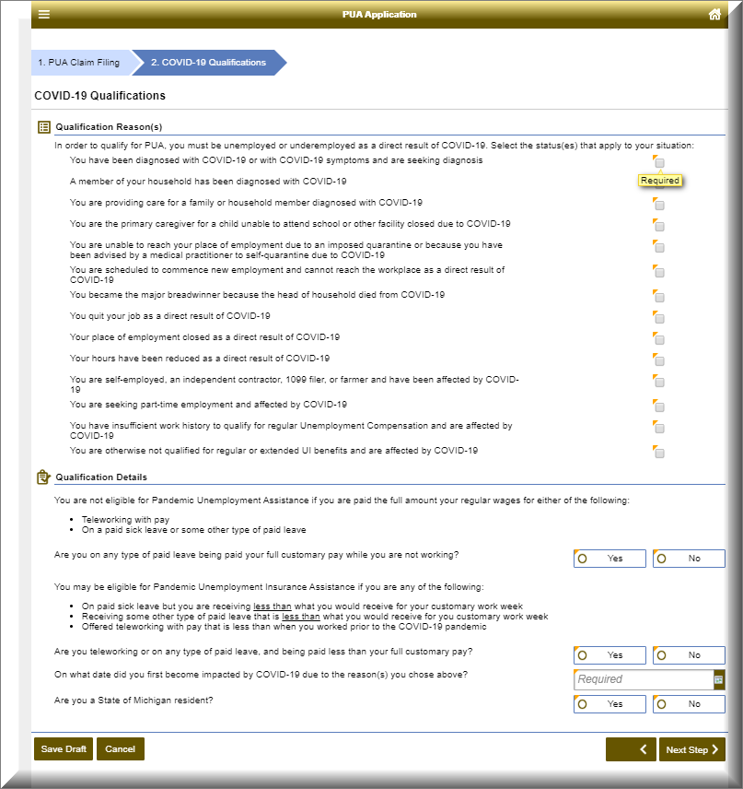

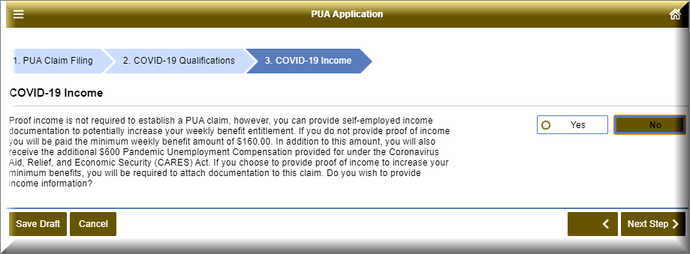

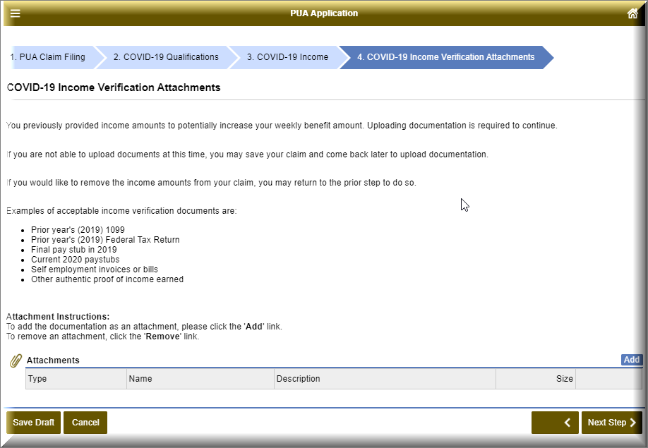
***NEED INFORMATION*** regarding how claimants filing on phone will be instructed to submit their information
The PUA screens for entering Identification Information, Address Information, Telephone, Additional Information (citizenship and tax withholding questions) and Payment Method screens are the same as current screens during filing process.
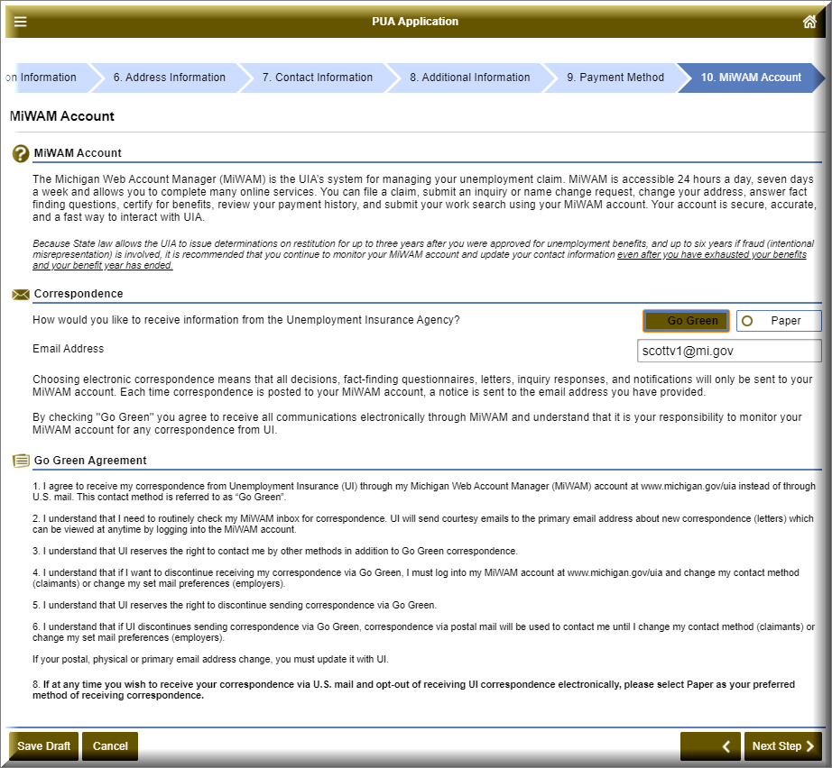
Note: Additional information is provided when the claimants choose “Go Green”
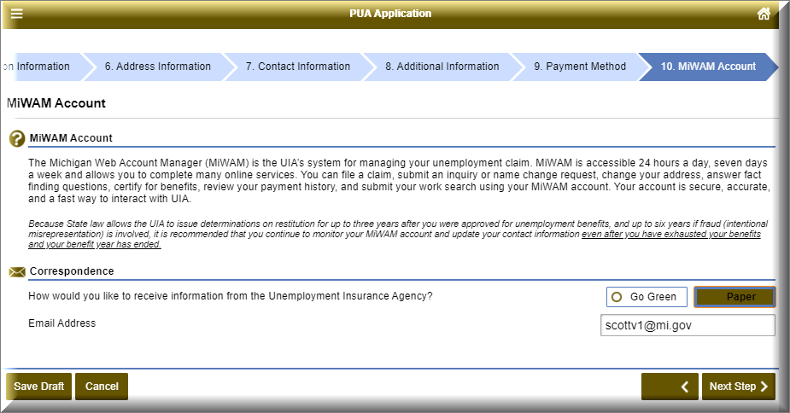
Note: This screen appears if claimant chooses Paper

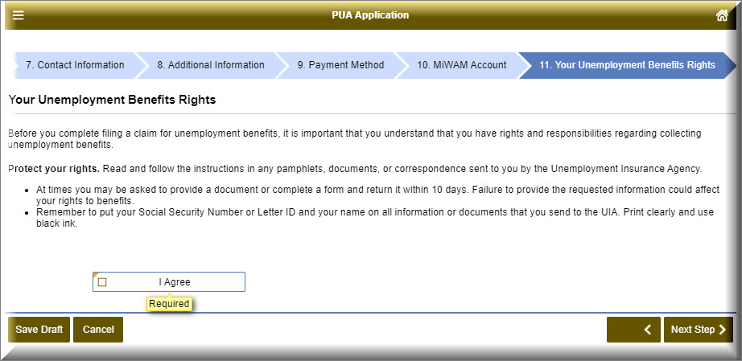
Note: Benefit rights have been abbreviated
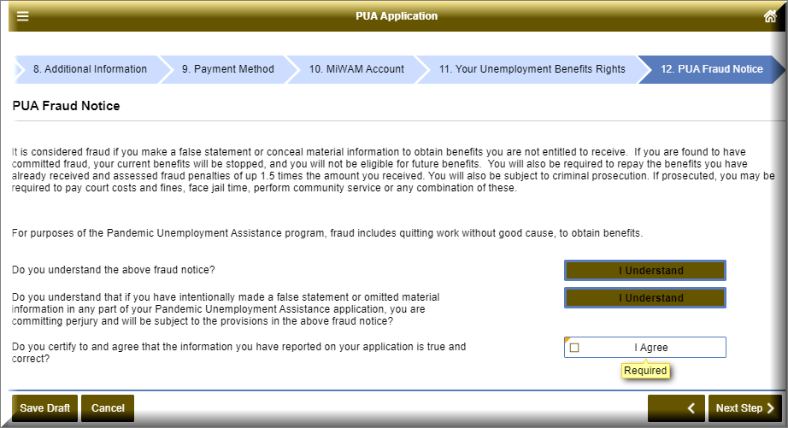
Note: Fraud information specific to PUA
